LIFT REPORT

FOR

Raine & Horne

AT

Macquarie Gardens
1 Fontenoy Road Macquarie Park

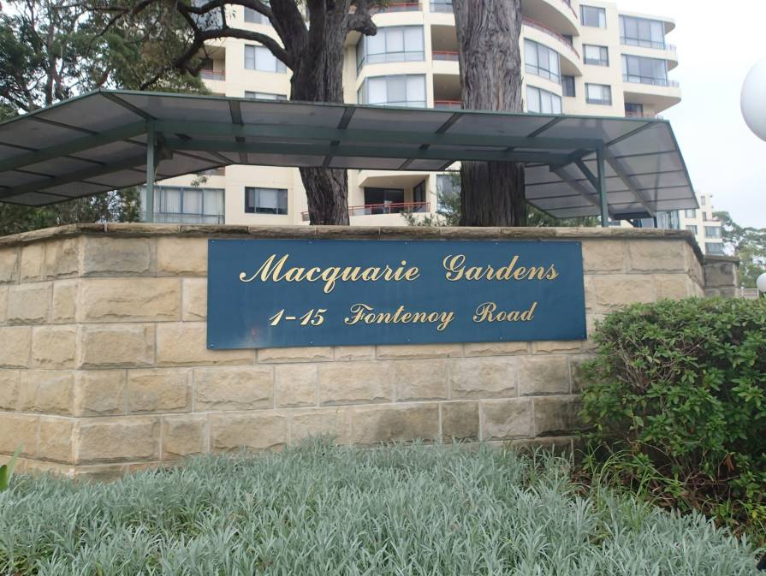

VTMS
PO BOX 820 Dapto NSW AUSTRALIA
PH. +(612) 4262 8711 FX +(612) 4262 8799 M. +(61) 0411 829 000

INTRODUCTION

An inspection of the 4 lifts was carried out on the 18th February 2014.

The following report indicates current condition, non-compliance and future anticipated upgrade works and costs.

DESCRIPTION OF EQUIPMENT

There are 4 passenger lifts installed on the property. One in each residential tower. The property is a modern apartment complex close to the M2 Motorway and the Macquarie Shopping Centre. The lifts were originally installed in approximately 1995. The lifts were manufactured and installed by the Liftronic.

The lift consists of the following layout.

NUMBER AND TYPE OF LIFTS : Lift 1 to 4 – Passenger Lifts

FLOORS SERVED : B, G 1 to 7

POWER SYSTEM : Geared machine located above
VVVF (Micompact 330)

CONTROL SYSTEM : Simplex Two Button Directional Collective
(Daldos)

DOOR TYPE : Two Panel, Centre Opening (GAL operator with Dupar locks)
(Lift 1 is a thru car)

DOOR PROTECTION : Electronic scanners

CAPACITY : 17 Persons / 1156 kgs

SPEED : 1.5 metres/second

MAINTENANCE

The lifts are now being maintained by ThyssenKrupp Elevator and the level of maintenance is of an acceptable standard.

The general housekeeping and tidiness was also acceptable although the shaft equipment requires a thorough clean down..

On specific matters of maintenance the following has been noted.

Lift 1

- Correctly mount and provide a cover for the main electrical fuses in the controller
- Replace missing screws in the lift car operating panel.
- Improve lift car ride quality. Acceleration and deceleration in particular is too rough.
- Clean car tops, pits and shaft equipment of dust, dirt and build up oil (all lifts)
- Repair oil leaks from the hoisting machine and remove oily rags

Lift 2.
- Provide a cover for the main electrical fuses in the controller
- Correctly install all controller relays
- Make all lift machine room lights operative and replace missing light guarding
- Make lift car alarm button operative on battery power
- Tighten loose bolts on the hoisting rope keeper plate at the top of the lift shaft.
- Correctly adjust all landing door upthrusts.
- Install cover to power door operator on the lift car roof

Lift 3
- Terminate or remove old redundant wiring in the controller
- Check operation of lift car emergency phone and increase speaker volume
- Install guarding to traction sheave in the lift shaft
- Improve lift car ride quality. Acceleration and deceleration in particular is too rough.
- Replace missing covers to all equipment on the lift car roof
- Replace rusty hoisting ropes.
- Correctly and permanently terminate the hoisting machine fan wiring
- Replace worn power door operator drive belt

Lift 4

- Remove or terminate all redundant wiring in the lift machine room (e.g. old mains cables)
- Replace all worn and pitted door hanger rollers.
- Install cover to power door operator unit on top of the lift car
- Terminate or remove old redundant wiring in the controller
- Replace missing cover of drive unit in the controller
- Replace rusty hoisting ropes.

We have also shown all of the above points on a separate page at the end of this report; you should forward this to your lift maintenance contractor requesting them to rectify the defects under the terms of their comprehensive maintenance agreement.

There are also a few items that are not covered by the maintenance contract that the owner should attend to.

- There has been water in the lift pits, notably lift 4. The entry of any further water should be monitored and prevented (if at all possible).
- The Ground floor landing door of lift 3 is badly damaged. The door panel should be replaced.

RELIABILITY

A detailed review of all lift malfunctions has been carried out over the previous 12-month period 17 February 2013 to 16 February 2014. This review revealed the following statistics:

TOTAL 29 Faults

These overall statistics were then further redefined, in greater detail, into the following specific areas:

Lift No. | Doors | Interference | R O A | Controller | Other | Total per Lift
Lift 1 | 2 | 0 | 0 | 1 | 2 | 5
Lift 2 | 3 | 0 | 1 | 6 | 0 | 10
Lift 3 | 5 | 0 | 2 | 2 | 0 | 9
Lift 4 | 2 | 0 | 2 | 0 | 1 | 5
Total per Fault | 12 | 0 | 5 | 9 | 3 | 29

Definitions of Faults
- Controller. These are faults directly attributed to the control system such as fuses, processor lock up, drive faults, etc.
- Doors. Any fault attributed to the door such as out of mesh, timed out, scanner faults, locks, etc.
- Interference. These are faults that cannot be controlled by the lift contractor and are often charged to the client as additional work. Wilful damage by others, incorrect use by others, power failure, etc.
- ROA. Running On Arrival. When a mechanic attends a breakdown and the unit is working correctly it is known as an ROA. There may have been no problem to begin with or there may be an intermittent fault that may only appear infrequently.
- Other. This can be anything other than the items listed. Often there had not been any apparent problems and no fault could be found. Very similar to an ROA.

The reliability of a lift is expressed as the numbers of faults per lift per month. Obviously the lower the number of faults the better. The number of faults will vary with the age and usage of the lifts as well as the type of lift and standard of maintenance applied. Interference calls are not counted as they as outside of the control of the lift contractor.

Lift No 1 | 0.42 Faults/Lift/Month
Lift No 2 | 0.83 Faults/Lift/Month
Lift No 3 | 0.75 Faults/Lift/Month
Lift No 4 | 0.42 Faults/Lift/Month

Average 0.61 Faults/Lift/Month

Fault Summary:

Taken as an overall average, 0.61 faults/lift/month is slightly higher than we would expect. A breakdown rate of approximately 0.5 faults/lift/month or less would not be unusual for lifts of this type, usage and vintage.

Clearly most of the faults are coming from the doors and controllers. These items should be reliable (although crude, rough and noisy in operation) and we suggest a more concerted effort in maintenance will reduce the fault rate accordingly.

The most unreliable lifts are Lifts 2 and 3. Lift 2 had intermittent faults with its controller and lift 3 mostly with its doors.

CONDITION

The motor room equipment is in an acceptable condition.

The buildings are of a reasonable height. The lifts serve from the basement car park up to level 7 in each apartment tower. The towers are only interconnected at basement and Ground levels. The lifts are very useful for carrying groceries and large objects. The lifts are also necessary for persons with disabilities or limited mobility.

The lift controller in each lift machine room is the original item installed in the mid 1990's. This type of controller is reasonably “intelligent”, but its electronic processor is of an older design. It should, however, be reliable and robust. Spare parts are still available at this time.

The drive is a modern variable speed AC item. These types of drives should provide accurate floor levelling of the lift car and provide good ride quality. At the moment the ride quality is not acceptable on several lifts. This should be able to be rectified by correctly adjusting the drives and ensuring the existing equipment is working as it should.

The door operation can be improved with replacing worn parts, e.g. door hanger rollers, and correctly adjusting the existing equipment. The doors will however not be able to operate as well as most new lifts due to the design of the door operator and lock system.

COMPLIANCE

Although the lifts would have complied fully with the relevant standards at the time of installation, the standards have changed considerably and consideration should be given to upgrade the lift to make it compliant.

As far as compliance with the lift code is concerned the lifts do not fully comply with the latest lift code.

The following are a few examples of non compliance.

- There are no lift shaft access devices on every landing
- There is no upward run away protection
- The lift pit buffer and governor do not have safety switches
- There is no safe space sign on the lift pit floor
- No guard rail on lift car top

A budget estimate to rectify the above issues is $15,000.00 to $20,000.00 per lift

To comply with the standard “Facilities for the disabled” there should be voice annunciation, tactile/Braille buttons, hand rails and improved lighting inside the lifts.

Whilst none of these compliance issues will improve the lifts' performance or reliability they are all aimed at improving safety for the maintenance mechanics and lift passengers.

CONCERNS

The lift pit (of at least lift 4 and 2) has water in it in the past. The pit should then be monitored by the lift contractor and the owners informed if more water enters the pit.

The hoisting ropes of lifts 3 and 4 are rusting and should be replaced. This is not urgent at this time but we suggest the work be done within the next 12 months.

MODERNISATION

We do recommend a modernisation be considered soon as the existing lift equipment, although is still serviceable and parts are available at this time, will become more unreliable and difficult to maintain. As the controller in particular has some old electronics in it, it is not clear how much longer parts will remain available.

We suggest that in the next 5 years or so consideration should be given to an upgrade of at least the lift controller, door operator/locks, lift car and landing buttons and indication.

The cost of this would be $150,000 to $200,000 per lift.

Regardless of any of the above being carried out there are numerous small compliance items (see previous section of this report titled Compliance) that need attention; we would suggest these be carried out along with the modernisation.

The lifts can also be completely replaced with a Machine Room Less type of lift (MRL). This would provide a fully compliant modern lift. The cost to remove the old lift, install a new MRL lift as well as builders works would be approximately $220,000.00 to $280,000 + GST per lift.

SUMMARY

The lifts are relatively modern but the electronics are becoming old and obsolete. The lift doors are noisy and provide poor operation. The lifts do not comply fully with the latest codes and standards and is not 100% suited for persons with disabilities. Their only redeeming features are that they are robust and (should be) reliable.

We have included a separate list of maintenance items that require attention under the terms of the comprehensive contract. We suggest this be passed on directly to ThyssenKrupp requesting them to attend to all items under the terms of their contract. We suggest you request a schedule of work from them so that completion of defects can be followed up.

The lifts should be operating better than they are now by a more concerted effort from ThyssenKrupp in improving ride quality and reducing some repetitive faults. The lifts will however require modernisation eventually and we suggest you consider doing this within the next 5 years or so while spare parts are still available and to allow the owners to acquire the appropriate funds.

We trust you will find our report helpful and should you require any further information or clarification, please do not hesitate to contact the undersigned.

Yours Faithfully

Mike Wood
Consultant

Pictures and Contractor's Items List

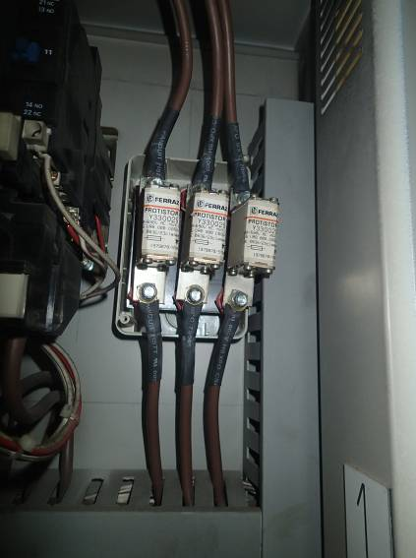

All controller main fuses must be correctly installed and covered

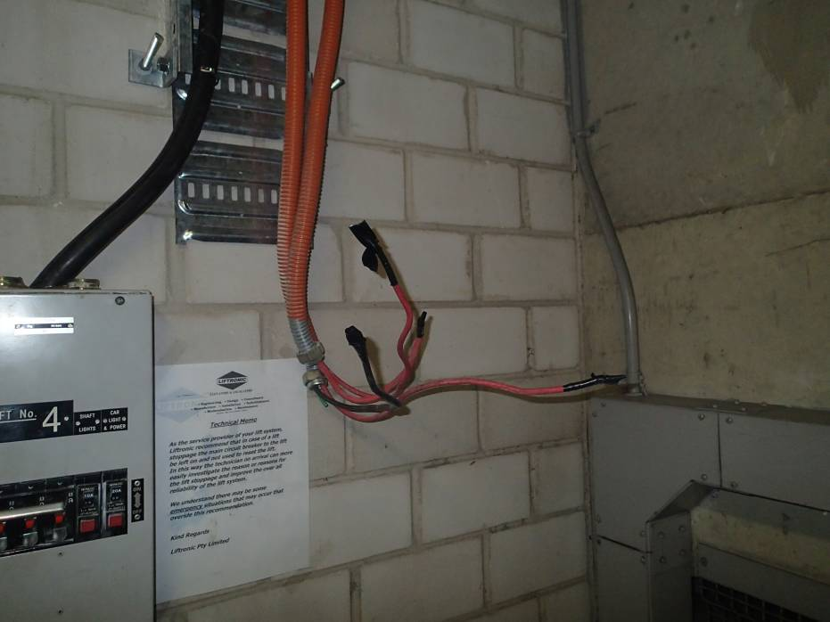

Old lift mains must be removed or safely terminated

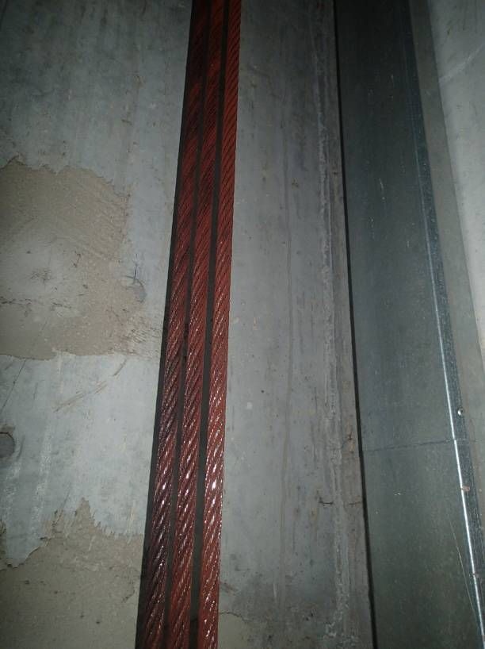

Rusty hoisting ropes must be replaced

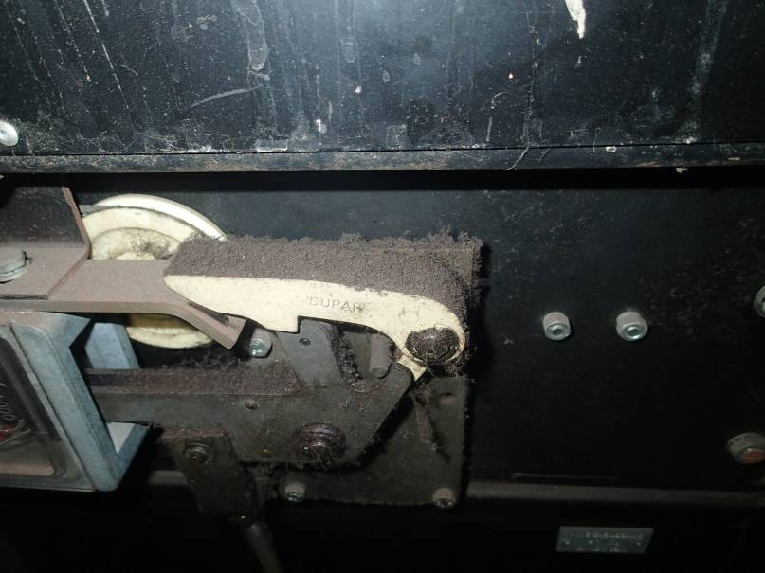

All lift shaft equipment must be cleaned

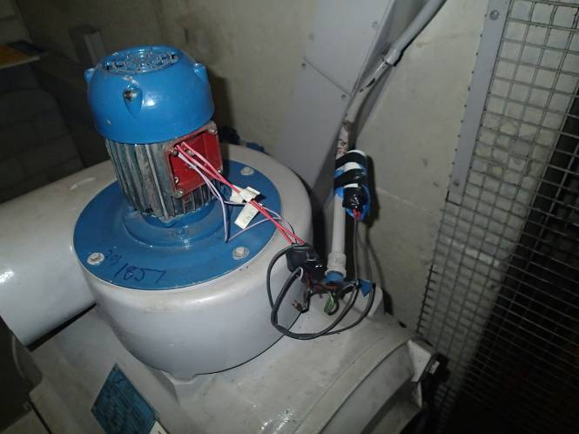

Hoisting machine fan wiring must be correctly terminated

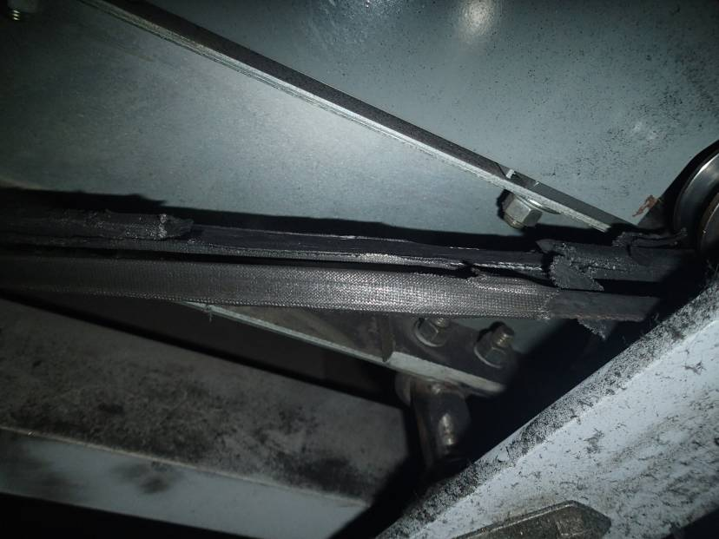

Worn power door operator drive belts must be replaced before they fail

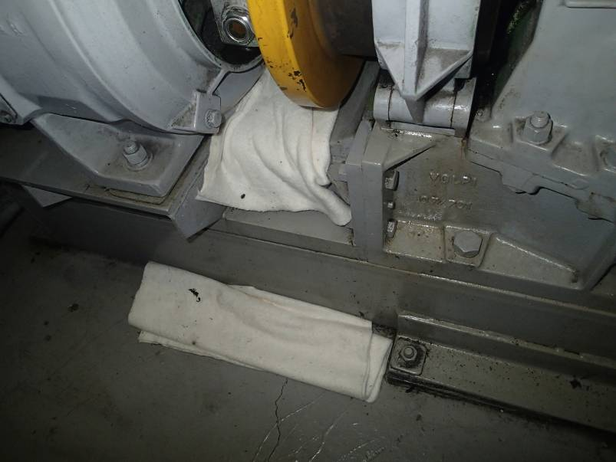

Hoisting machine oil leaks must be repaired and oily rags removed

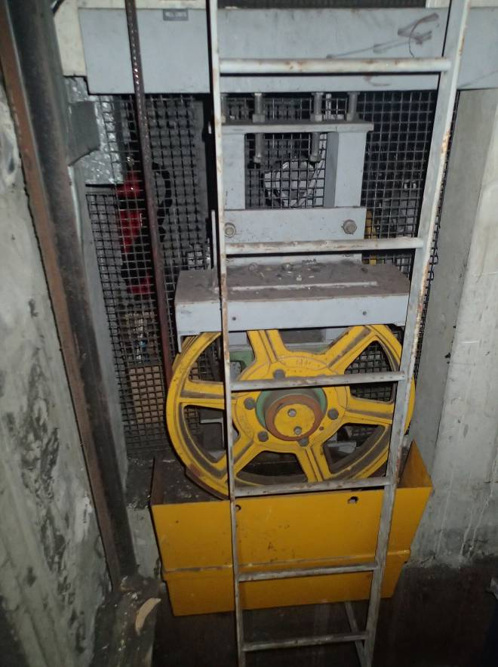

Traction sheave guards must be correctly installed

CONTRACTOR'S RESPONSIBILITIES

Lift 1

- Correctly mount and provide a cover for the main electrical fuses in the controller
- Replace missing screws in the lift car operating panel.
- Improve lift car ride quality. Acceleration and deceleration in particular is too rough.
- Clean car tops, pits and shaft equipment of dust, dirt and build up oil (all lifts)
- Repair oil leaks from the hoisting machine and remove oily rags

Lift 2.
- Provide a cover for the main electrical fuses in the controller
- Correctly install all controller relays
- Make all lift machine room lights operative and replace missing light guarding
- Make lift car alarm button operative on battery power
- Tighten loose bolts on the hoisting rope keeper plate at the top of the lift shaft.
- Correctly adjust all landing door upthrusts.
- Install cover to power door operator on the lift car roof

Lift 3
- Terminate or remove old redundant wiring in the controller
- Check operation of lift car emergency phone and increase speaker volume
- Install guarding to traction sheave in the lift shaft
- Improve lift car ride quality. Acceleration and deceleration in particular is too rough.
- Replace missing covers to all equipment on the lift car roof
- Replace rusty hoisting ropes.
- Correctly and permanently terminate the hoisting machine fan wiring
- Replace worn power door operator drive belt

Lift 4
- Remove or terminate all redundant wiring in the lift machine room (e.g. old mains cables)
- Replace all worn and pitted door hanger rollers.
- Install cover to power door operator unit on top of the lift car
- Terminate or remove old redundant wiring in the controller
- Replace missing cover of drive unit in the controller
- Replace rusty hoisting ropes.

